Frontend Development with React.js

Project Documentation format

**1.Introduction**

**Project Title:STORE MANAGER: KEEP TRACK OF INVENTORY**

Team Members:

1. **C. MANIKANDAN**:[ project manager ,fronted developer]

**2) M .DURAISAMY :** [desingner]

**3) S.NANDHAKUMER :**[Backend developer]

**4) R.SURENDHAR :**[project video creator]

**2.Project Overview**

**PURPOSE**:OPTIMIZE STOCK LEVELS

**FEATURES:**REAL TIME INVENTORY UPDATES

**3.Architecture**

## component structure :

App :root component

Navbar: navigation bar

Productform :add or update products

State Management:

Use redux toolkit or context apl to mange inventory data and golpal app state

## Routing:

Implement React Router for navigation between Dashboard, Product Management, and Reports pages.

**4.Setup Instructions**

## Prerequisites:

Node.js,npm/npm

## Installation:

https://github.com/manigandan72007-source/store-manager.git

git clone

https://github.com/s9440786-arch/Fitflex-_your-personal-fitness-companion.git

cd store-manager

npm install

npm start

**5.Folder Structure**

## Client:

src/

├── components/

│ ├── Navbar.js

│ ├── Dashboard.js

│ ├── ProductList.js

│ ├── ProductForm.js

│ ├── InventoryAlerts.js

│ └── SearchFilter.js

├── redux/ (or context/)

│ ├── store.js

│ ├── productSlice.js

└── App.js

Utilities: custom hooks for APL calls,formatter,etc

**6.Running the Application**

Provide commands to start the frontend server locally.

Frontend: npm start

**7.Component Documentation**

## Key Components:

ProductList: Displays products with CRUD actions

ProductForm: Handles add/update product

InventoryAlerts: Shows low-stock warnings

Reusable Components:button,model,table,inputfiled..

**8.State Management**

Global State: inventory list,selected product,alerts

Local State: form inputs,model visibiliity

**9.User Interface**

## Provide screenshots :

**Dashboard view**

**Product list**

**Add/edit product form**

**10.Styling**

## CSS Frameworks/Libraries:

tailwind css or material-ui

Theming: custom theme for consistent coloursand typography

**11.Testing**

Testing Strategy: Unit testing with Jest + React Testing Library, integration tests for API calls

Code Coverage: Ensure coverage for major components and reducers

**12.Screenshots or Demo  
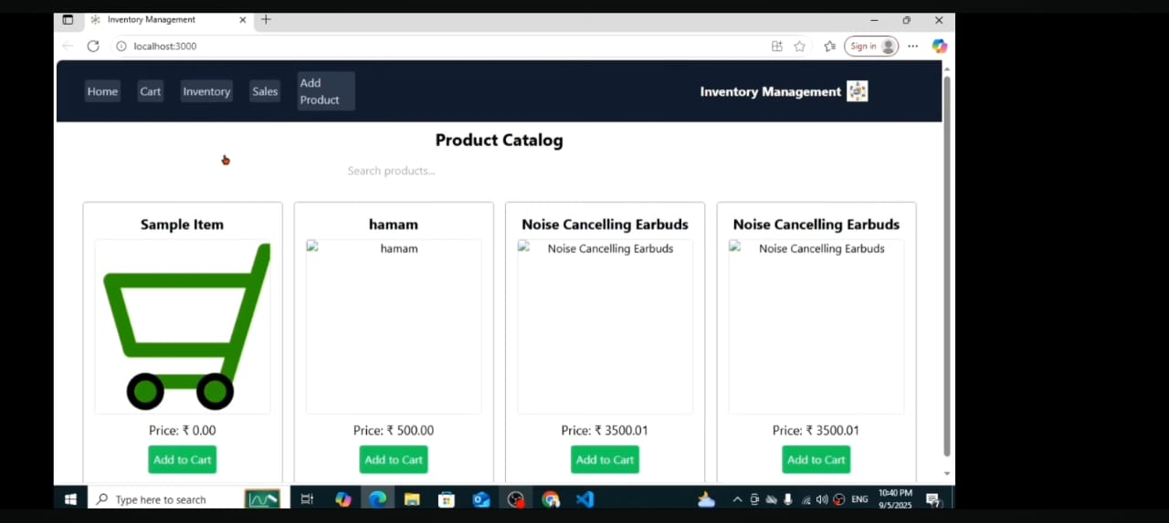**

https://github.com/manigandan72007-source/store-manager.git

**13.Known Issues**

Pagination for product list not yet implemented

No offline support

**14.Future Enhancements**

Barcode scanner integration

Export inventory data to CSV/Excel

Role-based access control (e.g., admin vs. staff)

Mobile app version